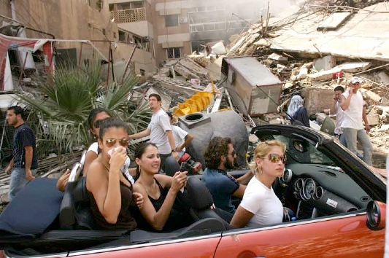
- Describe:
In the background, a large building complex lies in ruins. A small group of people are walking amidst the debris resulting from the building's collapse. In the foreground, a luxurious convertible is parked in front of the rubble. The car contains four women and one man who appear to be very conscious of their surroundings. 3 of the women and the man are wearing sunnglasses, while one doesn’t. The women in the middle of the car without the glasses is taking a picture with her phone of her surroundings. The women on the passenger seat is wearing a clean white shirt and shes looking somwhere we can’t see. The Man, who is the Driver seems entirely focused on the Road. The woman is the left backseat of the car is obstructed by the woman on the right backseat. She is holding a handkerchief to her mouth and nose. The locals don't seem to mind the people in the car and walk past it and the destroyed building.

-Interpret:
This image captures the intricate and uneasy duality of tourism in regions affected by conflict and natural disasters. Tourists are motivated by curiosity and a wish to see the worlds harsh realities, but unknowingly teeter upon a stark divide. On one side are those whose lives have been disrupted by tragedy. On the other are those who visit to observe their difficulties. The issue of "disaster tourism" prompts ethical and practical questions about the enduring inequalities within our global society.

-Verify:
This it the World Press Photo from the year 2007. the photo was taken in Dahiye, a neighborhood of Beirut after the first day of ceasefire. In the car are young Lebanese people who in fact drove through the city in a red convertible
Source:
https://www.telepolis.de/features/Von-engen-T-Shirts-und-echten-Maedchen-3410276.html
https://www.spiegel.de/fotostrecke/world-press-photo-die-sieger-2006-fotostrecke-19235.html

-Evaluate:
I have a small aversion especially to the occupants of the vehicle. Especially because they drove into the bombed city on the first Armistice Day to take pictures and look around.

